Program PARAM3

Purpose: program of calculation of active and inductive resistances.
Title: SUBROUTINE PARAM3.
Formal parameters: no.
Common memory areas: unnamed; named AK3, B, BUL.
Called programs: no.
Algorithm:
Factor, defining the pulsation of the magnetic conductance of the air gap:
Δ_{ZR} = k_{δR} - 1 - 3. k_{δR} .z _{R} .b_{1R}/(π .p) ,
where:
for semi-closed rotor slots:
b_{1R} = z_{R} . ε² . ϕ_{B} .(1 - ε^{2 .} ϕ_{B}/6)/(π .p);
ϕ_{B} = 0,5 + 2/3 .(δ/ b_{cS})² - 1/3 .(1 + 0,08 .b_{cR}/δ)⁻¹;
ε = π .p .b_{cR}/(z_{R} .t_{ZR});
for closed rotor slots:
b_{1R} = 0 .
Resistance of the winding of the phase A, Ω:
r_{SA} = ρ_{c}.2 .(l_{S} + l_{L}) .W_{SA} .10⁻²/S_{SA} ,
Resistance of the winding of the phase B, Ω:
r_{SB} = ρ_{c} .2 .(l_{S} + l_{L}) .W_{SB} .10⁻²/S_{SB} ,
Resistance of the winding of the phase C, Ω:
r_{SC} = ρ_{c} .2 .(l_{S} + l_{L}) .W_{SC} .10⁻²/S_{SC} .
Transformer factor for the phase В:
k_{B} = W_{SB} / W_{SA} .
Transformer factor for the phase C:
k_{C} = W_{SC} / W_{SA} .
Number of the stator slots by pole and phase:
q = z_{S} / (6 .p) .
Leakage slot factor of the winding of the stator for the forward and backward sequences:
for the trapezium slots:
λ_{PS} = 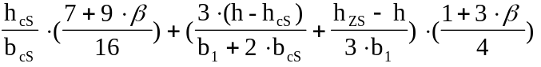,
for the semi-oval and oval slots:
λ_{PS} = 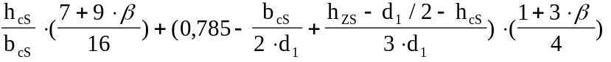,
where: β = y/τ,
τ = z_{S}/(2.p) .
Leakage slot factor of the winding of the stator for the zero sequence:
for the trapezium slots:
λ_{PS0} = 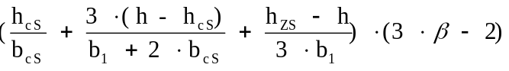
for the semi-oval and oval slots:
λ_{PS0} = 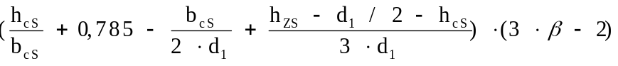,

Slot factor of the stator:
k_{δS} = 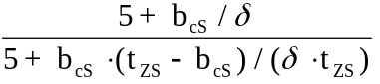.
Leakage end factor of the winding of the three-phase winding:
for single layer with concentric coils (number of coil groups is equal 2.p)
λ_{sS} = 0,47 .q .(l_{e} - D/p) / l_{S} .
for double layer
λ_{sS} = 0,39 .q .(l_{e} - β . D/p) / l_{S} .
Slot factor of the rotor
for semi-closed rotor slots:
λ_{sR} = λ‘_{sR} + h_{cR}/b_{cR} ;
for closed rotor slots:
λ_{sR} = λ‘_{sR} + 0,3;
where
for the oval slots:
λ‘_{sR} = 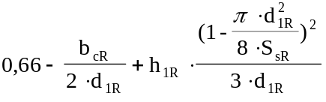.
h_{1R} = h₁₂ + 0,4 .d_{2R} ;
for the round slots:
λ‘_{sR} = 0,785 - 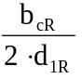
For six harmonics ν, taking into account at the equation system,it is calculating:
stator winding coefficients
k_{Wν} = 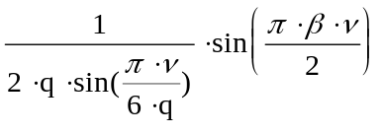;
skewing factor
k_{SKν} = 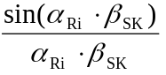,
where α_{Ri} = π .p .i / z_{R} , i = ν ;
leakage end factor of the winding of the rotor
λ_{eRν} = 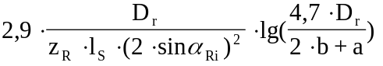,
for ν = 1 λ_{eR1} = λ_{eRν} ;
differetial leakage factor of the winding of the rotor
λ_{DRν}= 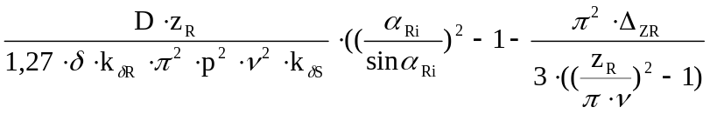;
slot and end leakage reactance of the winding of the rotor, referred to the winding of the phase A, Ω

x_{Rν} = 0,948 .10⁻⁶ .f .(W_{SA})² .l_{R} .( k_{Wν}/k_{SKν})² .( λ_{eR} + λ_{eRν})/z_{R} ;

differetial leakage reactance of the winding of the rotor, referred to the winding of the phase A, Ω
x_{DRν} = 0,948 .10⁻⁶ .f .(W_{SA})² .l_{R} .( k_{Wν}/k_{SKν}) .λ_{DRν}/z_{R} ;
resistance of the winding of the rotor, referred to the winding of the phase A, Ω
r_{Rν} = 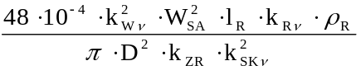.

Differetial leakage factor of the winding of the stator (for harmonics i ≠ ν, not taking into account at the equation system):
for the forward and backward sequences:
λ_{DS} = 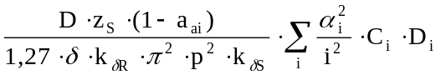,
for the zero sequence:
λ_{DS0} = 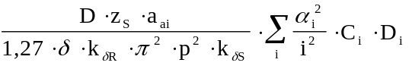,
where :
C_{i} - factors, taking into account the influence of the stator toothness on the amplitudes of the induction space harmonic of a magnetic field i ≠ ν and i ≠3
C_{i} = C_{ν} ;
D_{i} - factors, taking into account the influence of the rotor currents on the amplitudes of the induction space harmonic of a magnetic field i ≠ ν and i ≠3
D_{i} = 1 - (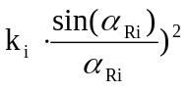 ;
k_{i} = 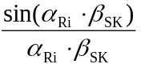;
α_{Ri} = π . p i z_{R} ;
α_{i} - stator winding coefficients for i ≠ ν: and i ≠3
α_{i} = 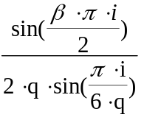;
a_{ai} = ⏐(sin(i.π/2) + sin(i.(π/2+2.π/3)) + sin(i.(π/2+4.π/3))⏐/3,
(a_{ai} = 1 for i - multiple 3, a_{ai} = 0, for i - no multiple 3)

For third harmonic:
stator winding coefficient
k_{W 3} = 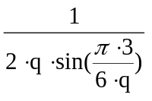;
skewing factor
k_{SK3} =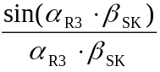,
where α_{R3} = π .p .3 / z_{R} ;
leakage end factor of the winding of the rotor
λ_{eR3} = 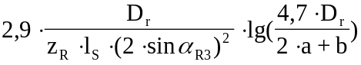;
differetial leakage factor of the winding of the rotor
λ_{DR3} = 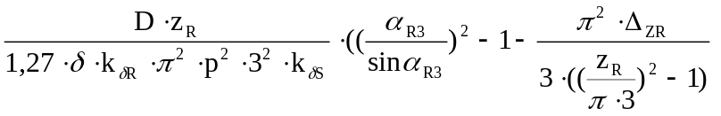;
slot and end leakage reactance of the winding of the rotor, referred to the winding of the phase A, Ω:
x_{R3} = 0,948 .10⁻⁶ .f .(W_{SA})² .l_{R} .(k_{W3}/k_{SK3})² .( λ_{sR} + λ_{eR3})/z_{R};

differetial leakage reactance of the winding of the rotor, referred to the winding of the phase A, Ω
x_{DR3} = 0,948 .10⁻⁶ .f .(W_{SA})² .l_{R} .( k_{W3}/k_{SK3}) .λ_{DR3}/z_{R};
resistance of the winding of the rotor, referred to the winding of the phase A, Ω
r_{R3} = 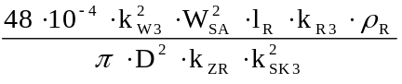.
Slot and end leakage reactance of the stator winding of the phase A, Ω:
x_{SA1} = 0,948 .10⁻⁶ .f .(W_{SA})² .l_{S} .( λ_{sS} + λ_{eS})/z_{S} .
Slot and end leakage reactance of the stator winding of the phase B, Ω:
x_{SB1} = 0,948 .10⁻⁶ .f .(W_{SB})² .l_{S} .( λ_{sS} + λ_{eS})/z_{S} .
Slot and end leakage reactance of the stator winding of the phase C, Ω:
x_{SC1} = 0,948 .10⁻⁶ .f .(W_{SC})² .l_{S} .( λ_{sS} + λ_{eS})/z_{S} .
Slot and end leakage reactance of the stator winding for the zero sequences, referred to the winding of the phase A, Ω:
x_{SA0} = 0,948 .10⁻⁶ .f .(W_{SA})² .l_{S} .( λ_{sS0} + λ_{eS})/z_{S} .
Differetial leakage reactance of the stator winding of the phase A for the forward and backward sequences, Ω:
x_{DA} = 0,948 .10⁻⁶ .f .(W_{SA})² .l_{S} .λ_{DS}/z_{S} .
Differetial leakage reactance of the stator winding of the phase B for the forward and backward sequences, Ω:
x_{DB} = 0,948 .10⁻⁶ .f .(W_{SB})² .l_{S} .λ_{DS}/z_{S} .
Differetial leakage reactance of the stator winding of the phase C for the forward and backward sequences, Ω:
x_{DC} = 0,948 .10⁻⁶ .f .(W_{SC})² .l_{S} .λ_{DS}/z_{S} .
Differetial leakage reactance of the stator winding for the zero sequences, referred to the winding of the phase A, Ω:
x_{D0} = 0,948 .10⁻⁶ .f .(W_{SA})² .l_{S} .λ_{DS0}/z_{S} .

